MD2201: Data Science

Name of the student: Shrinivas Hatyalikar Roll No. 24

Div: B Batch: B1

Date of performance: 17/11/2022

Experiment No.5

Title: Classifier.
Aim: To apply Nearest Neighbor algorithm.

Software used: Programming language R.

Code Statement:
Consider 18 points data set referred in theory class. Consider test sample P(3,2). Apply following algorithms to find the class of this test point.
- NN
- KNN with K=5
- R-NN Radius based algorithm with radius as 1.45 units.

Code:
f1=read.csv("knn1_csv.csv")
ed= sqrt((f1$x-3)**2+(f1$y-2)**2)
f1=cbind(f1,ed)
f1_sort=f1[order(f1$ed),]
#NN Algorithm
cat("\n class of P for NN is:",f1_sort[1,4])
#KNN Algorithm
df1=f1_sort[1:5,]
l1=sum(df1$class==1)
l2=sum(df1$class==2)
l3=sum(df1$class==3)
if (l1>l2&l1>l3)
cat("\n Class of P for KNN is:",1)
if (l2>l1&l2>l3)
cat("\n Class of P for KNN is:",2)
if (l3>l1&l3>l2)
cat("\n Class of P for KNN is:",3)
#RNN Algorithm
df2=f1_sort[f1_sort$ed<1.45,]
lr1=sum(df2$class==1)
lr2=sum(df2$class==2)
lr3=sum(df2$class==3)
if (l1>l2&l1>l3)

cat ("\n Class of P for RNN is:",1)
if (l2>l1&l2>l3)
cat("\n Class of P for RNN is:",2)
if (l3>l1&l3>l2)
cat("\n Class of P for RNN is:",3)

Results:

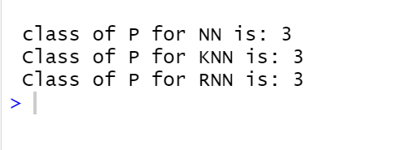

Conclusion:

The code in R helps us find the class for point P using all the nearest neighbor algorithms including NN ,KNN , RNN.

